AI-Augmented Backend Development Project:

TITLE: AI STUDDY BUDDY

Project Description

In a Single Paragraph
< Project Name > is an AI-Augmented backend Web Application developed using the (MongoDB, Express.js, Node.js) integrated with Artificial Intelligence capabilities such as Large Language Models (LLMs), Semantic Search, Vector Search, and Intelligent Recommendations. The system enables users to interact with data through natural language, receive AI-generated insights, perform semantic searches, upload and analyze documents, and automate decision-making processes. By combining traditional backend development with modern AI technologies, the platform delivers an intelligent, scalable, and user-friendly experience that improves productivity, accessibility, and operational efficiency.

Scenario
In today’s digital world, students regularly use digital learning resources to study, understand concepts, complete assignments, prepare for examinations, and improve their knowledge. However, managing a large amount of study material manually can be time-consuming and difficult. Students may face problems such as finding relevant learning resources, understanding difficult topics, organizing notes, revising important concepts, and getting quick answers to their questions. Traditional learning systems mainly depend on manual searching and studying, which can increase the workload and make personalized learning difficult.
Traditional systems are also limited in their ability to understand individual student requirements and learning contexts. Students may need to spend significant time searching through textbooks, notes, and online resources to find relevant information. They may also have difficulty identifying important topics, summarizing lengthy study materials, and preparing for examinations. These manual processes can result in confusion, inefficient learning, and difficulty in accessing useful information quickly.
Artificial Intelligence can improve the AI Study Buddy by analyzing study materials and understanding students’ learning requirements. AI can support features such as intelligent question answering, personalized study recommendations, automatic summarization, topic identification, quiz generation, and smart search. By integrating AI capabilities with the AI Study Buddy system, it can reduce students’ study workload, improve learning organization, provide personalized assistance, and help students understand and revise important concepts more quickly and effectively.
- Describe the Proposed Solution
Explain how your < Project Name > addresses the identified problem using AI capabilities such as:
  - AI Chatbot
  - Content Generation
  - Question Answering
  - Semantic Search
  - Vector Search
  - Intelligent Recommendations
  - Document Analysis
  - AI-powered Insights
structure
Paragraph 1 – Problem:
In the education domain, students often face difficulties in understanding lessons, finding relevant study materials, organizing notes, preparing for examinations, and getting quick answers to their questions. Manual searching for information can take considerable time and effort. Students may also find it difficult to identify important topics, understand complex concepts, and maintain well-organized study information. Traditional learning systems generally depend on textbooks, notes, and basic search methods, which may not understand the individual needs and learning context of students.

Paragraph 2 – AI Solution:
AI Study Buddy solves these problems by using Artificial Intelligence to make learning smarter and more efficient. The system can use AI for intelligent question answering, study material summarization, topic identification, personalized study recommendations, quiz generation, and smart search. These AI features help the application understand students’ learning requirements, reduce manual effort, and provide relevant learning information in a simple and accessible way.

Paragraph 3 – Impact:
AI Study Buddy can benefit students, learners, teachers, and educational institutions. It helps students understand difficult concepts, organize their study materials, prepare for examinations, and discover useful learning resources quickly. The application can reduce study time, improve learning efficiency, provide personalized assistance, and create a more interactive and effective learning experience.

System Requirements:
To ensure smooth development, deployment, and usage of the < Project Name > AI-Augmented Backend Application, certain system prerequisites must be met.

1. Software Requirements

Operating System
- Windows 10/11
- macOS
- Linux

Node.js (v18 or above)
Provides a runtime environment for frontend and backend development.

npm (v9 or above)
Package manager used for dependency installation.

Express.js
Backend framework used for API development.

MongoDB Community Server / MongoDB Atlas
NoSQL database used to store:
- User Information
- Chat History
- Documents
- Embeddings
- AI Interactions
- Application Data

MongoDB Atlas Search
Provides full-text search functionality.

MongoDB Atlas Vector Search
Enables semantic search using vector embeddings.

AI Service Provider
- OpenAI API
- Gemini API
- Claude API
- Azure OpenAI (Optional) …etc

LangChain / AI SDK
Used for orchestration of AI workflows.

Browser
- Google Chrome
- Mozilla Firefox

Postman
API Testing

Visual Studio Code
Development Environment

Git & GitHub
Version Control

2. Hardware Requirements

Processor
Intel Core i5 (8th Gen+) / AMD Ryzen 5+

RAM
Minimum 8 GB
Recommended 16 GB

Storage
Minimum 5 GB Free Space

Internet Connection
Required for AI API communication

Display
1366 × 768 or above

Project Architecture

Technical Architecture:

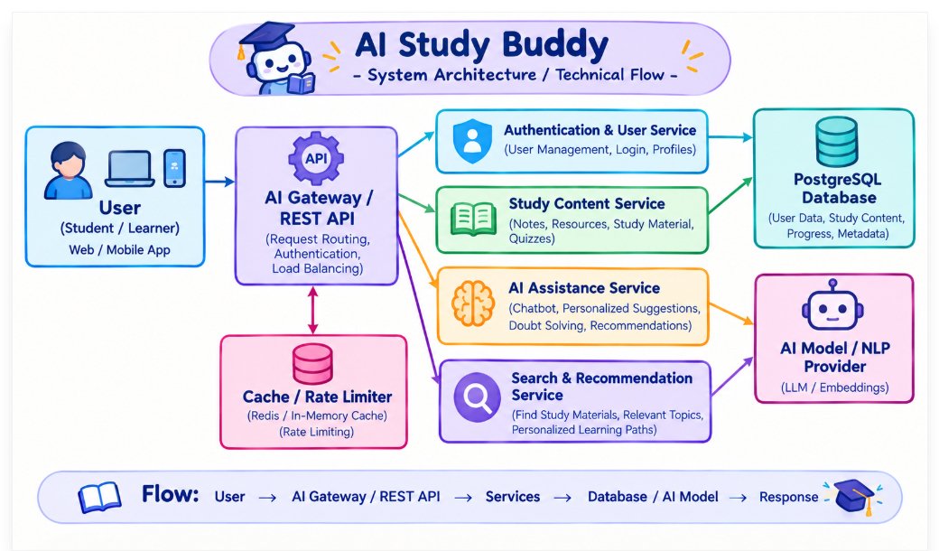

Backend Layer
- Node.js
- Express.js
- JWT Authentication
- REST APIs

Database Layer
- MongoDB
- Atlas Search
- Atlas Vector Search

AI Layer
- LLM APIs
- Embedding Models
- RAG Pipeline
- Prompt Engineering

Storage Layer
- MongoDB Collections
- File Upload Storage

Security Layer
- JWT Authentication
- Protected Routes
- Input Validation
- Role-Based Access Control

ER Diagram

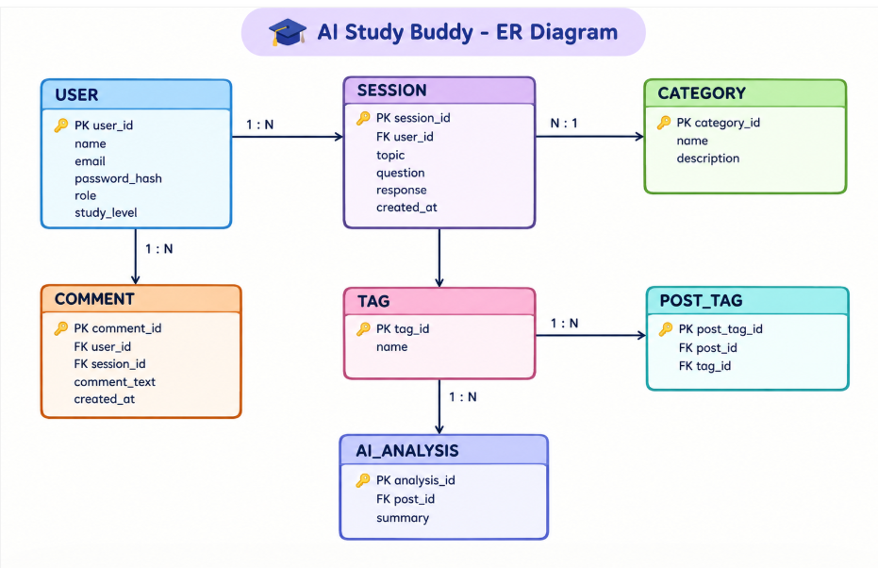

Collections

Users
- _id
- name
- email
- password
- role

Documents
- _id
- title
- content
- uploadedBy
- createdAt

Embeddings
- _id
- documentId
- vectorData

Chats
- _id
- userId
- prompt
- response
- timestamp

ActivityLogs
- _id
- userId
- activity
- createdAt

ER Diagram Explanation
Users can upload documents and interact with AI features. Uploaded documents are processed into vector embeddings and stored in MongoDB. Chat interactions and AI responses are logged for future reference and analytics. Activity logs maintain user actions across the system.

Features

Core Backend Features
- User Registration
- User Login
- JWT Authentication
- Protected Routes
- Middleware
- CRUD API
- File Upload
- Role-Based Access Control

AI Features
- AI Chat Assistant
- Semantic Search
- Vector Search
- Document Question Answering
- Text Summarization
- Content Generator
- RAG (Retrieval Augmented Generation)
- Intelligent Insights
- Natural Language Queries

Roles and Responsibilities

Admin
- Manage Users
- Manage Documents
- Monitor AI Usage
- View Analytics
- Configure System

User
- Register/Login
- Upload Documents
- Ask Questions
- Search Content
- View AI Recommendations
- Manage Personal Data

User Flow
- User Registration
- User Login
- JWT Authentication
- Dashboard Access
- Upload Documents
- Generate Embeddings
- Store Vectors in MongoDB
- User Query Submission
- Semantic Search Execution
- AI Response Generation
- Display Results
- Store Chat History

MVC Pattern
The backend follows the MVC (Model-View-Controller) architecture.

Model Layer
Responsible for:
- User Schema
- Chat Schema
- Document Schema
- Embedding Schema
- Activity Schema
Implemented using Mongoose.

Controller Layer
Responsible for:
- Authentication Logic
- AI API Integration
- Document Processing
- Embedding Generation
- Search Operations
- CRUD Operations

View Layer (Routes)
Defines REST API endpoints:

Authentication Routes
- Register
- Login
- Logout

AI Routes
- Chat
- Summarization
- Semantic Search

Document Routes
- Upload
- View
- Delete

User Routes
- Profile
- Dashboard

Advantages of MVC
- Separation of Concerns
- Better Maintainability
- Easy Scalability
- Reusable Components
- Team Collaboration
- Easier Testing

Project Setup and Configuration

Project Structure
Create Project Folder
Inside Project Folder:

Server Folder
Backend Application

Server Setup
mkdir server

cd server

npm init -y
Create:
server.js

models/
controllers/
routes/
middlewares/
config/
services/
utils/


Install Backend Packages
npm install express mongoose cors dotenv bcryptjs jsonwebtoken

npm install openai

npm install multer

npm install nodemon --save-dev


Backend Development
Include:
- Authentication APIs
- JWT Implementation
- AI Service Integration
- Vector Search APIs
- CRUD APIs
- Document Upload APIs
- Chat APIs
Note:
Proper explanation must be provided for every AI API consumed, including:
Purpose:
AI Study Buddy is designed to provide personalized learning support through an intelligent API. It helps students understand concepts, ask questions, generate explanations, create study materials, track learning progress, and receive personalized recommendations using AI capabilities.

Request Structure:
The API request contains information such as the student ID, subject, topic, question, learning level, study preferences, or requested learning activity. The request is sent to the appropriate API endpoint using methods such as POST or GET.

Response Structure:
The API provides a structured response containing AI-generated explanations, answers, summaries, study notes, quiz questions, learning recommendations, or relevant study resources. Responses are returned in JSON format with status information and requested learning data.

Cost Considerations:
The system should consider costs associated with AI model usage, API requests, database storage, cloud hosting, and processing of learning data. Caching repeated queries, optimizing API calls, and selecting suitable AI models can help reduce unnecessary processing and operational costs.

Security Practices:
AI Study Buddy should protect student accounts and learning information through secure authentication and authorization. HTTPS encryption, input validation, secure API keys, access control, rate limiting, and protected database access should be implemented to prevent unauthorized access and maintain the privacy of student data.

Database Development
Include:
- MongoDB Collections
- Relationships
- Atlas Search Index
- Vector Search Index
- Sample Documents
Provide screenshots and explanation.

Project Execution

Step 1: Backend
cd server

npm install


Step 2: Configure Environment Variables
Create .env
PORT=8000

MONGO_URI=mongodb://localhost:27017/ai_augmented_db

JWT_SECRET=your_secret_key

OPENAI_API_KEY=your_api_key


Step 3: Run Backend
nodemon server.js
Backend URL:
http://localhost:8000


Output with Explanation

API Testing:

API testing is used to verify that all AI Study Buddy API endpoints function correctly. It checks student requests, question processing, authentication, response accuracy, JSON formats, error handling, and API performance under different learning scenarios.

LLM Integration:

The Large Language Model (LLM) is integrated into AI Study Buddy to understand students’ questions and provide intelligent learning assistance. It can explain difficult concepts, generate summaries, create study notes, answer questions, and provide step-by-step guidance.

AI Chat Interface:

The AI chat interface allows students to communicate with AI Study Buddy using natural language. Students can ask doubts, request explanations, summarize topics, practice questions, and receive personalized learning support through an interactive chat system.

Document Upload:

Students can upload learning materials such as PDF, DOCX, and text files. AI Study Buddy processes the uploaded documents to extract important information, generate summaries, create questions, and help students understand the study material.

Search Results:

The search feature helps students quickly find relevant study materials, topics, notes, and learning resources. Natural-language search allows the system to understand the meaning of a student's query and return useful results related to the requested subject or topic.

Recommendation Engine:

The recommendation engine analyses the student's learning interests, selected subjects, previous activities, and study progress to provide personalized learning suggestions. It can recommend suitable topics, study materials, quizzes, and practice activities to support effective learning.

Demo Video Link
Demo video

Source Code Drive Link

Code files

Mandatory Functionalities
- MVC Architecture
- JWT Authentication
- Semantic Search
- MongoDB Atlas Search
- MongoDB Atlas Vector Search
- Prompt Engineering
- AI API Integration
- Role-Based Access Control

